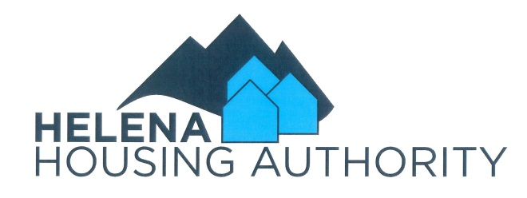

Working at Helena Housing Authority offers the opportunity to positively impact the lives of residents and to serve the Helena Community. HHA offers a challenging and dynamic work environment that allows you to succeed. Team members work together on a variety of projects to meet our common goal of providing safe and affordable housing and related services to eligible, low-income families, the elderly, and the disabled.
The Helena Housing Authority seeks a Public Housing Specialist for a range of duties to include client relations, housing program and policy administration, rent collection/accounting, coordinating maintenance, resolving tenant complaints, providing customer service, managing records, writing reports and other related tasks.
Duties Include:
- Establish and maintain an effective landlord/renter relationship with HHA clients to ensure compliance with lease agreements and housing regulations and safe and comfortable living arrangements.
- Perform recordkeeping and reporting by collecting and maintaining a variety of housing program data and preparing reports for the Board and federal and state partner agencies.
- Initiate work orders for repairs by maintenance staff.
- Collect payment of deposit and rent. Meet with tenants to resolve overdue issues; prepare and send overdue notices, initiate eviction process for nonpayment. Post payment to the accounting and management information system (YARDI)
- Perform various other duties such as completing special projects, attending meetings and conferences, maintaining an awareness of emergency service networks and being available for a rare occasional after hours need to attend a scheduled resident meeting, or to help respond to emergency/immediate client issues.

Qualifications to Join our Team: Requires education and experience equivalent to a college degree or vocational/technical training and two years’ experience. Requires strong client relations skills; customer service or related experience; possession of, or ability to obtain, a valid Montana Driver’s License with a driving record acceptable to insurance carriers; and the ability to work extended hours, if needed. Must pass a background check. HHA will provide training opportunities in Public Housing Rent Calculation, Public Housing Management, Low Income Tax Credit Compliance, and Fair Housing. Experience in public housing or affordable housing is preferred.

Demonstrated Skills and Abilities in: Communications and teamwork, self-development, efficiency and effectiveness, adaptability to changes and problem-solving skills.

Computer Skills:
- Microsoft Office Suite, including Word, Access, Excel and Power Point
- Windows based applications
- Internet Explorer
- Outlook

Anticipated New Hire Salary Range: $21/hr. ($44,000/yr.) - $25/hr. (52,000/yr.) plus a generous benefit package including significant paid leave.

Opportunities: The HHA Public Housing Specialist Career Ladder currently offers a Public Housing Specialist career salary range for highly experienced, highest performing individuals to achieve individual and organizational performance increases and opportunities to earn up to $33.65/hr. or $70,000 per year through promotion.
Benefits: HHA offers great benefits including participation in the Montana Public Employees Retirement System (PERS) and Deferred Compensation plans, Health, Vision and Dental Insurance with contributions to a health savings plan: Short-Term Disability, Life, and Accidental Death & Dismemberment with optional coverages; and a generous paid leave program including 11 holidays, 12 days of sick leave, and 15 days of vacation leave per year increasing with years of service up to 24 days per year.
Public Service Loan Forgiveness (PSLF): - Employment with Helena Housing Authority may qualify you to receive student loan forgiveness under the PSLF. Check if you qualify at https://myfedloan.org/borrowers/special-programs
How to apply: Submit a cover letter, resume and completed HHA Application Form either by mail to P.O. Box 1251, Helena, MT 59624 or electronically at khoxie@cmsmontana.com.

Applications must be received by 5:00 P.M. March 10, 2022, to be considered for the first round of screenings. If a suitable candidate is found in that screening, no further consideration will be made of applications received after that date. The position remains open until filled. We look forward to talking to you.

Questions: Please call 442-4934 or email khoxie@cmsmontana.com.
HHA is an Equal Opportunity Employer.

