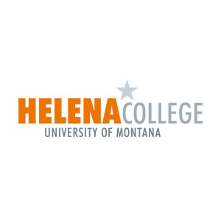Helena College University of Montana

**Performance Evaluation System**

**Employee Self Evaluation Questionnaire**

**Name Date**

**Position Evaluation Period**

**As a part of the evaluation process, use this form to review, describe, and evaluate your job performance over the past evaluation period. Share this form with your supervisor prior to your evaluation meeting for submittal with your annual performance evaluation for your file.**

1. What were your most significant work-related accomplishments? (Include projects, assignments, new skills or knowledge gained.)

1. How do these accomplishments relate to your key responsibilities and goals for you and your unit/department?

1. What didn’t you accomplish that you had planned on accomplishing? Why?

1. What are your goals for the next evaluation period?

1. How will you accomplish these goals?

1. What do you need to accomplish these goals?

1. How can your supervisor help you to work more effectively and support your goals?

1. How can your team help you achieve your goals?

1. What additional training or development would help you improve and/or enhance your work performance?

1. What feedback or suggestions do you have to improve your unit and/or department?