Book Adoption FAQ’s

- My course doesn’t have an adoption. Am I still required to do anything?
  - Yes. You will need to select “I’m not using any materials for this class” on the adoption overview page. Your students will see a message on the virtual bookstore and in the booklist posted on our website letting them know that there are no required texts.
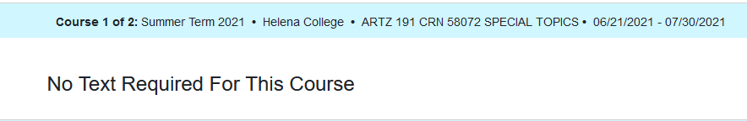
- I use open-source materials that are free to my students. Am I still required to do anything?
  - Yes. You will still indicate what materials you are using in your course. You will need to select “I’m not using any materials for this class” on the adoption overview page. The click on slider that says, “Are you using Open Education Resources?” Clicking the word “No” will change the slider to green and the word “Yes” will display.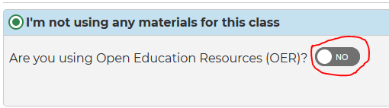
The virtual bookstore will indicate that students need to acquire their materials from another source. The published booklist on the campus store site will direct them to their materials.
  - Virtual bookstore
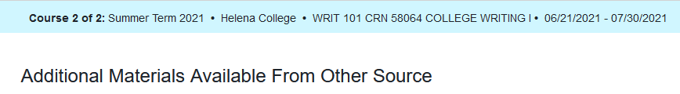
  - Campus store booklist
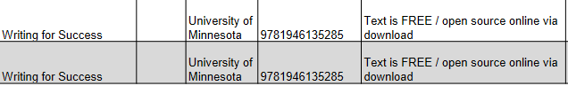

- My course has more than one adoption. What do I do?
  - If you are readopting from a prior term you should see all of your course materials and you can select to readopt all of them. If you do not see all of your desired materials you can still readopt the title that does appear by submitting it and then select “I’d like to be guided through the adoption process” to adopt additional materials.
  - If you are adopting all new materials, or your prior adoptions are incorrect or not displaying, select “I’d like to be guided through the adoption process” to adopt your materials. You will submit each material one at a time.
- My course requires a book and online course access; can I pull the ISBN from the back of my book?
  - No. If you require a book and digital media you will need to find the ISBN provided by the publisher for the bundle.
- I want my students to be able to choose between print and etext; how do I indicate that?
  - You will list the ISBN’s for both print and etext in the ISBN column. In comments please indicate that students only need 1.
